NHAPL Fall Member Social

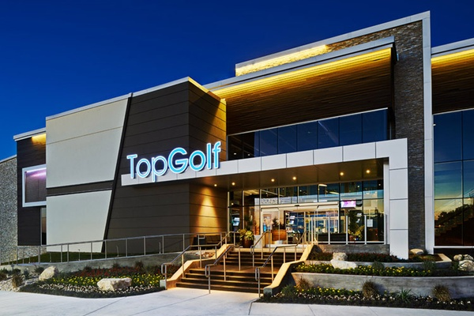

Hosted at Top Golf Spring

Come join the NHAPL for food and drinks at our annual Fall Social! The event is free for members of the NHAPL and $35 for non-members. You can also sign up for membership for $35 online at www.NHAPL.org.

Sponsorships are welcomed! Please fill out the sponsor form attached if you wish to be a sponsor. Your support of the NHAPL is greatly appreciated!

Thursday, September 10, 2015 from 5:00-8:00

Please RSVP online at www.NHAPL.org. We’ll see you there!

Top Golf Spring, 560 Spring Park Center Blvd, Spring, TX 77373
www. NHAPL.org

